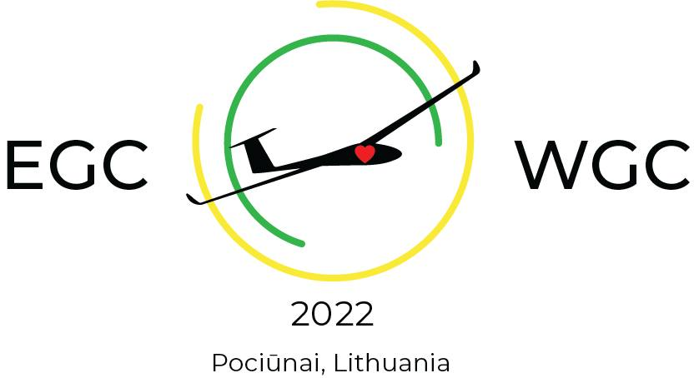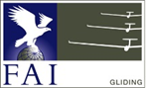

NAC Registration form

COUNTRY:

NAC:

Each NAC can enter up to 3 pilots per Class. Regning World Champions can be entered in addition.
This form is the official NAC Registration Form. Additional data shall be entered for all pilots in the on-line form on the competition web-site(https://egc2022wgc.pociunai.lt/).
Please scan and e-mail the signed form to director@pociunai.lt not later than 31st March 2022 where also entry fee shall be paid in accordance with the Local Procedures.

TEAM CAPTAIN:

Team Captain’s e-mail: GSM phone number:
Pilot | Class | Glider type | Reg. | CN | Remarks

Name, function and signature NAC stamp

